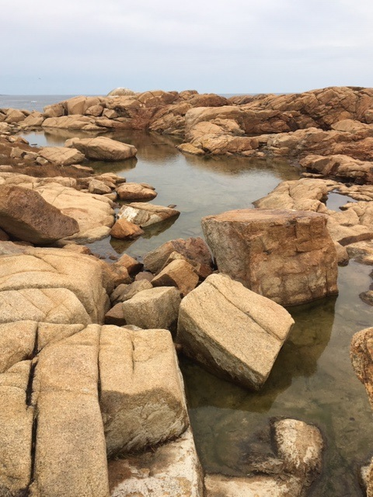

Be Still and Know: A Contemplative, Centering Prayer Weekend
Friday, March 13 – Sunday, March 15, 2020
This weekend, anchored in silence and the practice of Centering Prayer, offers opportunities to rest in body and in God while enjoying the emerging spring beauty of Eastern Point Retreat House on the shore of Gloucester, MA. The schedule includes three centering prayer gatherings, an overview of the practice, evening prayer, lectio divina and (weather permitting) a labyrinth and other outdoor contemplative walks. Remaining hours are unscheduled for private prayer and reflection. A Catholic liturgy will be offered Saturday before dinner. No previous experience with centering prayer is necessary. Fee of $382 includes overnight accommodations, program and all meals, beginning with dinner at 6:00 p.m. Friday night through lunch on Sunday. (All meals on Saturday through Sunday breakfast will be silent.). Guests may arrive anytime from 3 p.m. on Friday. The retreat program ends at noon on Sunday; lunch will follow. To register: visit www.easternpoint.org. Go to “Retreats,” and then to “2020 Registration” in the drop down.

Anne A. Simpkinson has been practicing Centering Prayer (CP) since 1996. A certified Introductory CP Workshop leader, she has led workshops and Quiet Days in New York City and Connecticut. While living in New York, she served as co-coordinator of Contemplative Outreach for three years and as a CP facilitator at St. Bartholomew's and St. Ignatius Loyola churches. She is co-facilitator of Mercy by the Sea Retreat and Conference Center’s (Madison, Connecticut) weekly and monthly Centering Prayer circles, and contemplative weekend retreats. Claire Rusowicz is a certified spiritual and retreat director, and spiritual director supervisor, with more than 20 years working with groups and individuals in Connecticut, New York and Massachusetts. She is co-facilitator of Mercy by the Sea’s weekly and monthly Centering Prayer circles and contemplative weekend retreats.

